**Day 8 Assignment| Linux Administration Essentials**

Assignment 0: 1. Create a simple shell script to tell the user about their session.

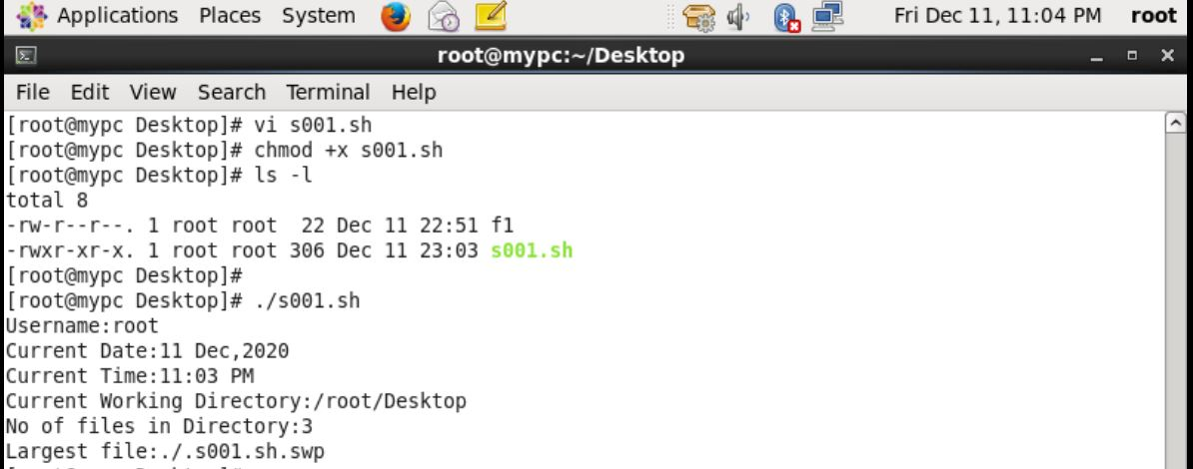

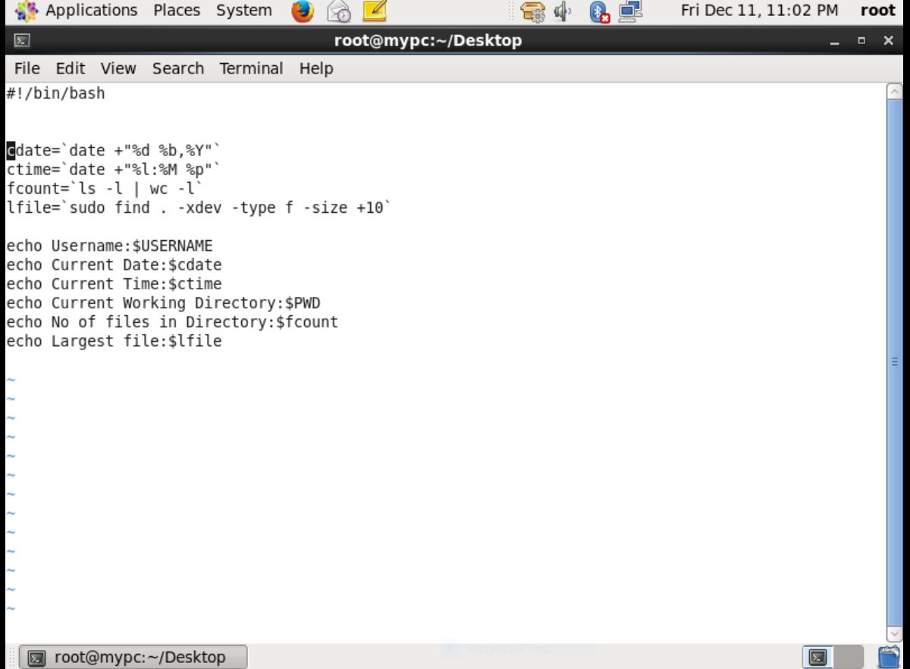

Assignment 1: Create a directory with a few text files in it (the files can be empty). Now write a script that for every file in that directory you rename it to have an extension of today's date in YYYYMMDD format.

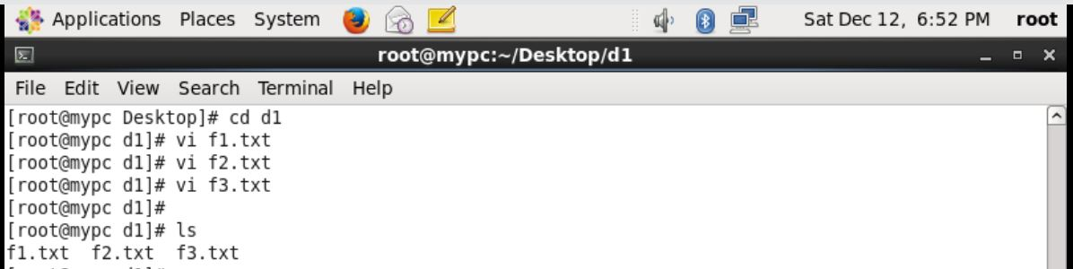

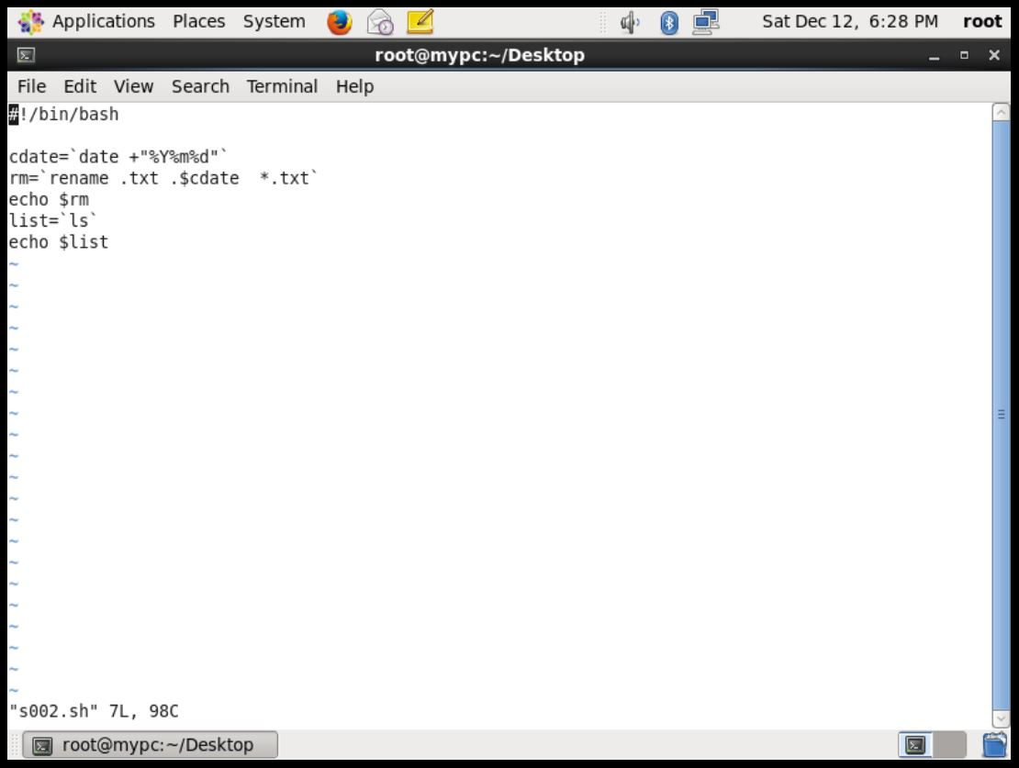

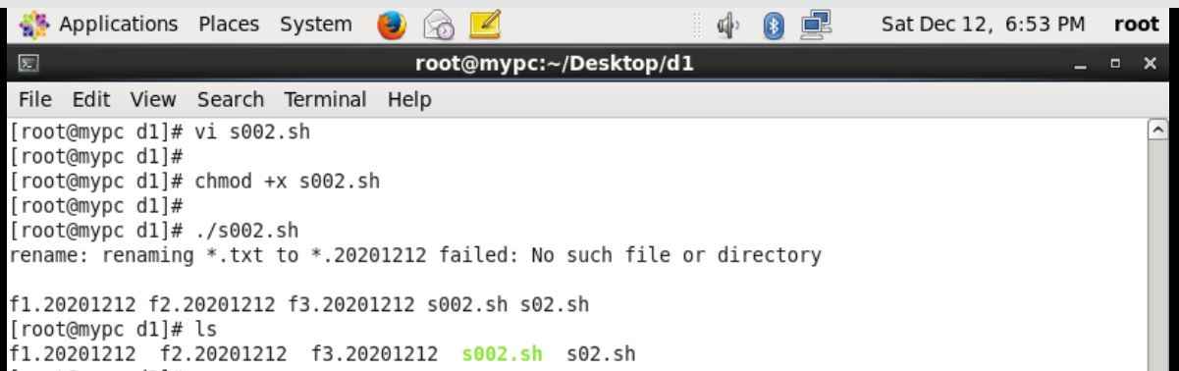

Assignment 2: Write a script that takes a number as an input and reverses it out to the user. For example, if the original number is 74985, the output should be 58947.

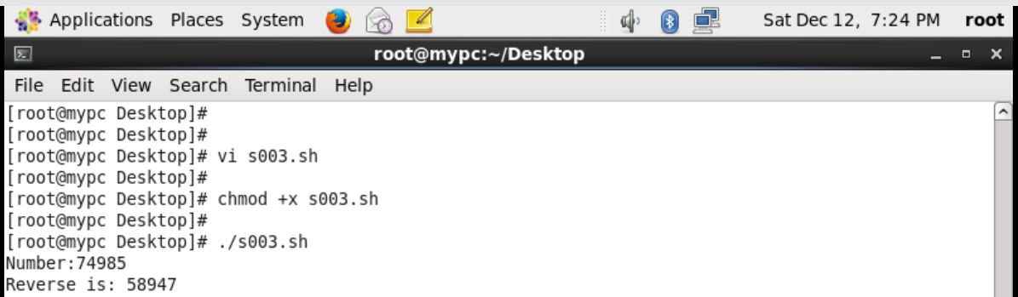

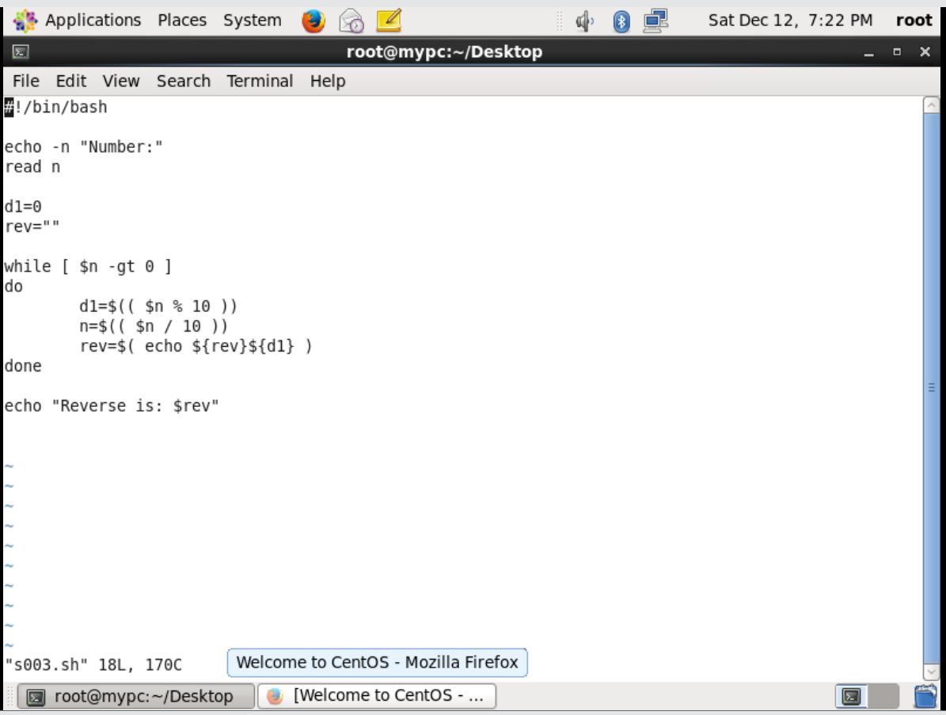

Assignment 3: Write a script to validate how secure someone's password is.

